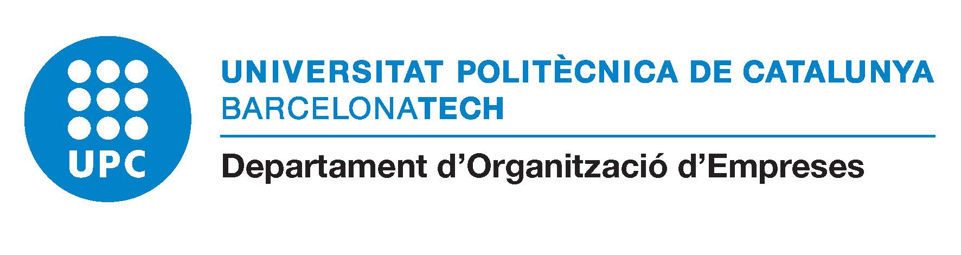

6th WORKSHOP ON TALENT MANAGEMENT
Barcelona, Spain – October 2-3, 2017

SOCIAL EVENTS

Monday October 2, 2017

It is planned a guided visit to the Faculty of Nautica of the UPC from 18:30 to 19:30 (https://www.fnb.upc.edu/content/historia-de-la-facultat). It is a building of Cultural Interest that we are going to visit in a tour and also we are going to have a guided visit to the planetarium (https://www.fnb.upc.edu/content/simuladors).

It is very easy to get there from the Palau Macaya (see attached a google maps view). Please, if you are interested in coming to this interesting visit let us know at the registration desk.

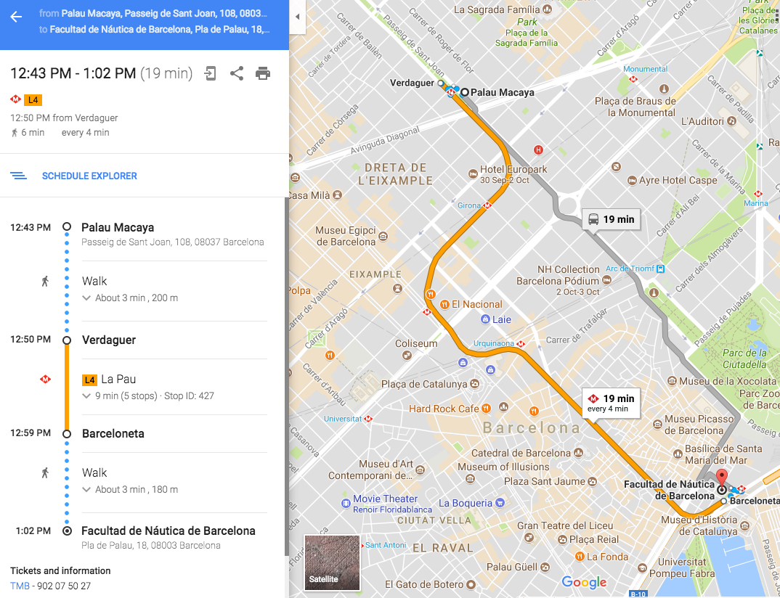

DINNER at the Restaurant 7 portes (https://7portes.com/en/)

The Faculty of Nautica is just in front of the restaurant in which we are going to have dinner
(3 min by walk)

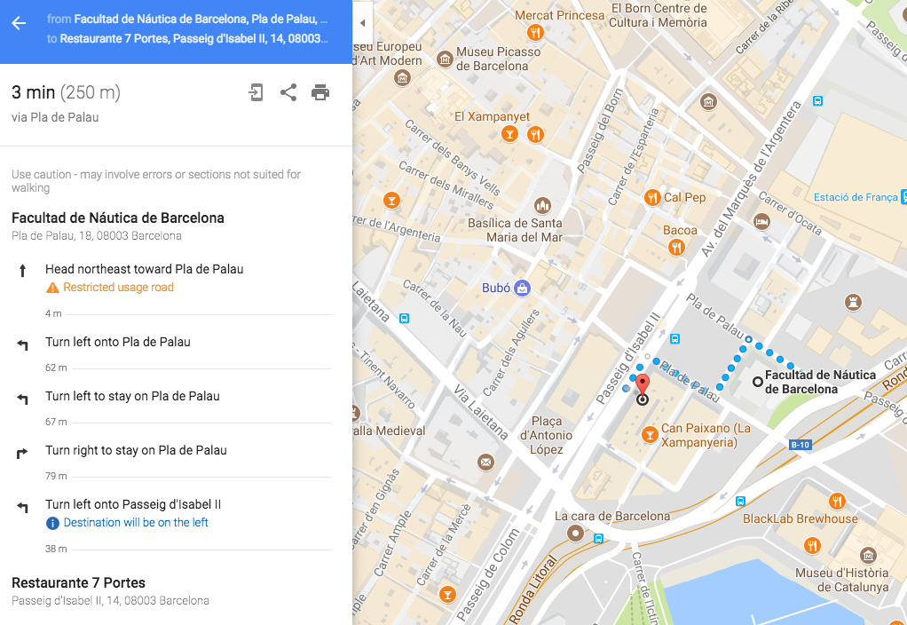

Tuesday October 3, 2017

Olive oil taste by Xavier Ruzafa (entrepreneur & CEO of The BOOC)
http://www.thebooc.com/en/

It is going to be as an appetizer just before lunch at the Palau Macaya.

